for more information contact: [karmaedje26@hotmail.come](mailto:karmaedje26@hotmail.come) or [haj.2506@gmail.com](mailto:haj.2506@gmail.com)



M ySTUDENT APP

user guide

ics 4u0

2015/2016

Kara Maedje and Hajra Rizvi

Overview

The MyStudent App is designed specifically for students based off of their school lives and academics. It offers balance between crucial and valuable information while providing easy - user friendly interactions and quick accessibility to a student’s daily needs.

How To Use MyStudent App – Guide Lines

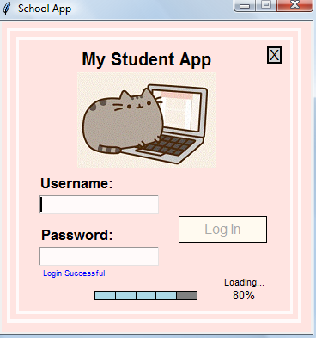

The usage of our app begins when the program first runs though the final_project.py file. It will then proceed to a login in window. In order to login, the user must reference the provided usernames and passwords based on the data files being processed. (Reference provided: password.txt file). If the user logs in with an invalid username or password, and error message will be displayed.

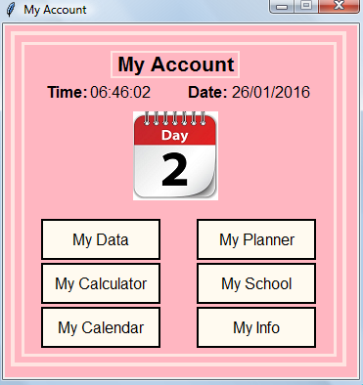After a successful login, a confirmation message will be displayed followed by a loading animation.

The user will then be taken to a main menu window where all of the available options for the app are offered. Take into consideration that this app is designed to perform data processing and provide accessibility to information. The user will have free will in terms of exploring the app without being timed or limited to rules, etc.

Features

**MyData:**

My data serves as an information hub in which students can have quick and accessible access to their academic needs. Information provided on this feature will include a displayed out time table of the students courses they are currently and will eventually be taking. They will be able to keep track of their teachers and rooms all while managing their time. Along with their time table, they will also have a calculated status of what their overall average is based on their current submitted data.

**Steps for Usage:** On the main menu, click on the MyData button. View the newly displayed window for as long as you’d like and reopen anytime while running the app.

**MyPlanner:**

MyPlanner is a feature that exists to help students keep their priorities intact. With MyPlanner, students can record notes and post them to a text file for viewing whenever they please. The text file will keep these notes saved for later reading and thus the student will never have to fear about import notices and date.

**Steps for Usage:** On the main menu, click on the MyPlanner button. On the next window, notes, save them and view them. Note that if you chose to view your notes, a new, refreshed window will open. To prevent an over excessive amount of opened windows, close each before viewing a new one. Be sure to hit the “CLOSE” button when done with MyPlanner instead of hitting the default exit button. You cannot open any of the other features until my MyPlanner is closed.

**MyCalculator**

MyCalculator is a simplistic calculator provided with ease. It functions with basic calculation options such as adding, subtracting, multiplication, division, etc. A calculator is a basic necessity to almost any student, with this app; you will always have one handy.

**Steps for Usage:** Click on the MyCalculator button on the main menu. Use the graphical calculator as you would with any other online calculator. Hit the exit button when done.

**MyCalendar**

MyCalendar displays a calendar of the current month with the date high-lighted. It updates daily so you’ll never have to fear what day it is and where you need to be.

**Steps for Usage:** Click the MyCalendar button and view the calendar on the new window. This window in non-interactive meaning it’s just for viewing.

**MySchool**

MySchool offers students key information determined by their school such as the schedules on modified dates i.e. Character Counts and Late Start days, and upcoming events like holidays and exams.

**Steps for Usage:** Click on the MyStudent button and view the contents of the window. This window is non-interactive as well and just for viewing.

**MyInfo**

MyInfo is a consistently updated feature that shares global social media updates and statues from others all across the internet; a source of Intel for students’ asides from their school lives!

**Steps for Usage:** Click on the MyInfo button and view the contents of the new updating window. This window is also non-interactive.